Once you complete your registration. There are two courses that NTX Soccer is requiring all of our coaches to complete prior to being assigned to their team.

https://home.gotsoccer.com/

Click on Team & Team Officials login
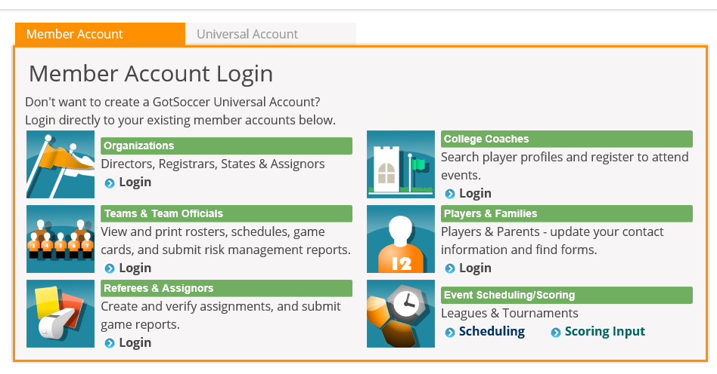

Login with the individual Coach Login that you created at registration.
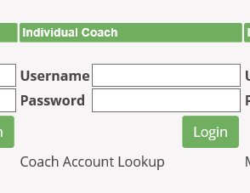

Once you login to your coach account, both courses will be showing and you can go in from there and complete the courses.

