Attention Coaches! We have moved away from the NMCSL Game Sheets that you are used to; filling in and printing prior to each game. Instead, you will go in to your team, within GotSport and generate your game reports from there. MAKE SURE YOU ARE SELECTING MATCH CARD WITHOUT PHOTOS.
U13+ must also have Player Cards
Step by step instructions below. You will provide the game report to your referees but they will not return them to you. Take a picture of the final game report from the referee and then you will go in to the schedule in Got Sport to enter the scores, instead of calling them in.

Login to your coach account, Click on Team Management and then select your team.

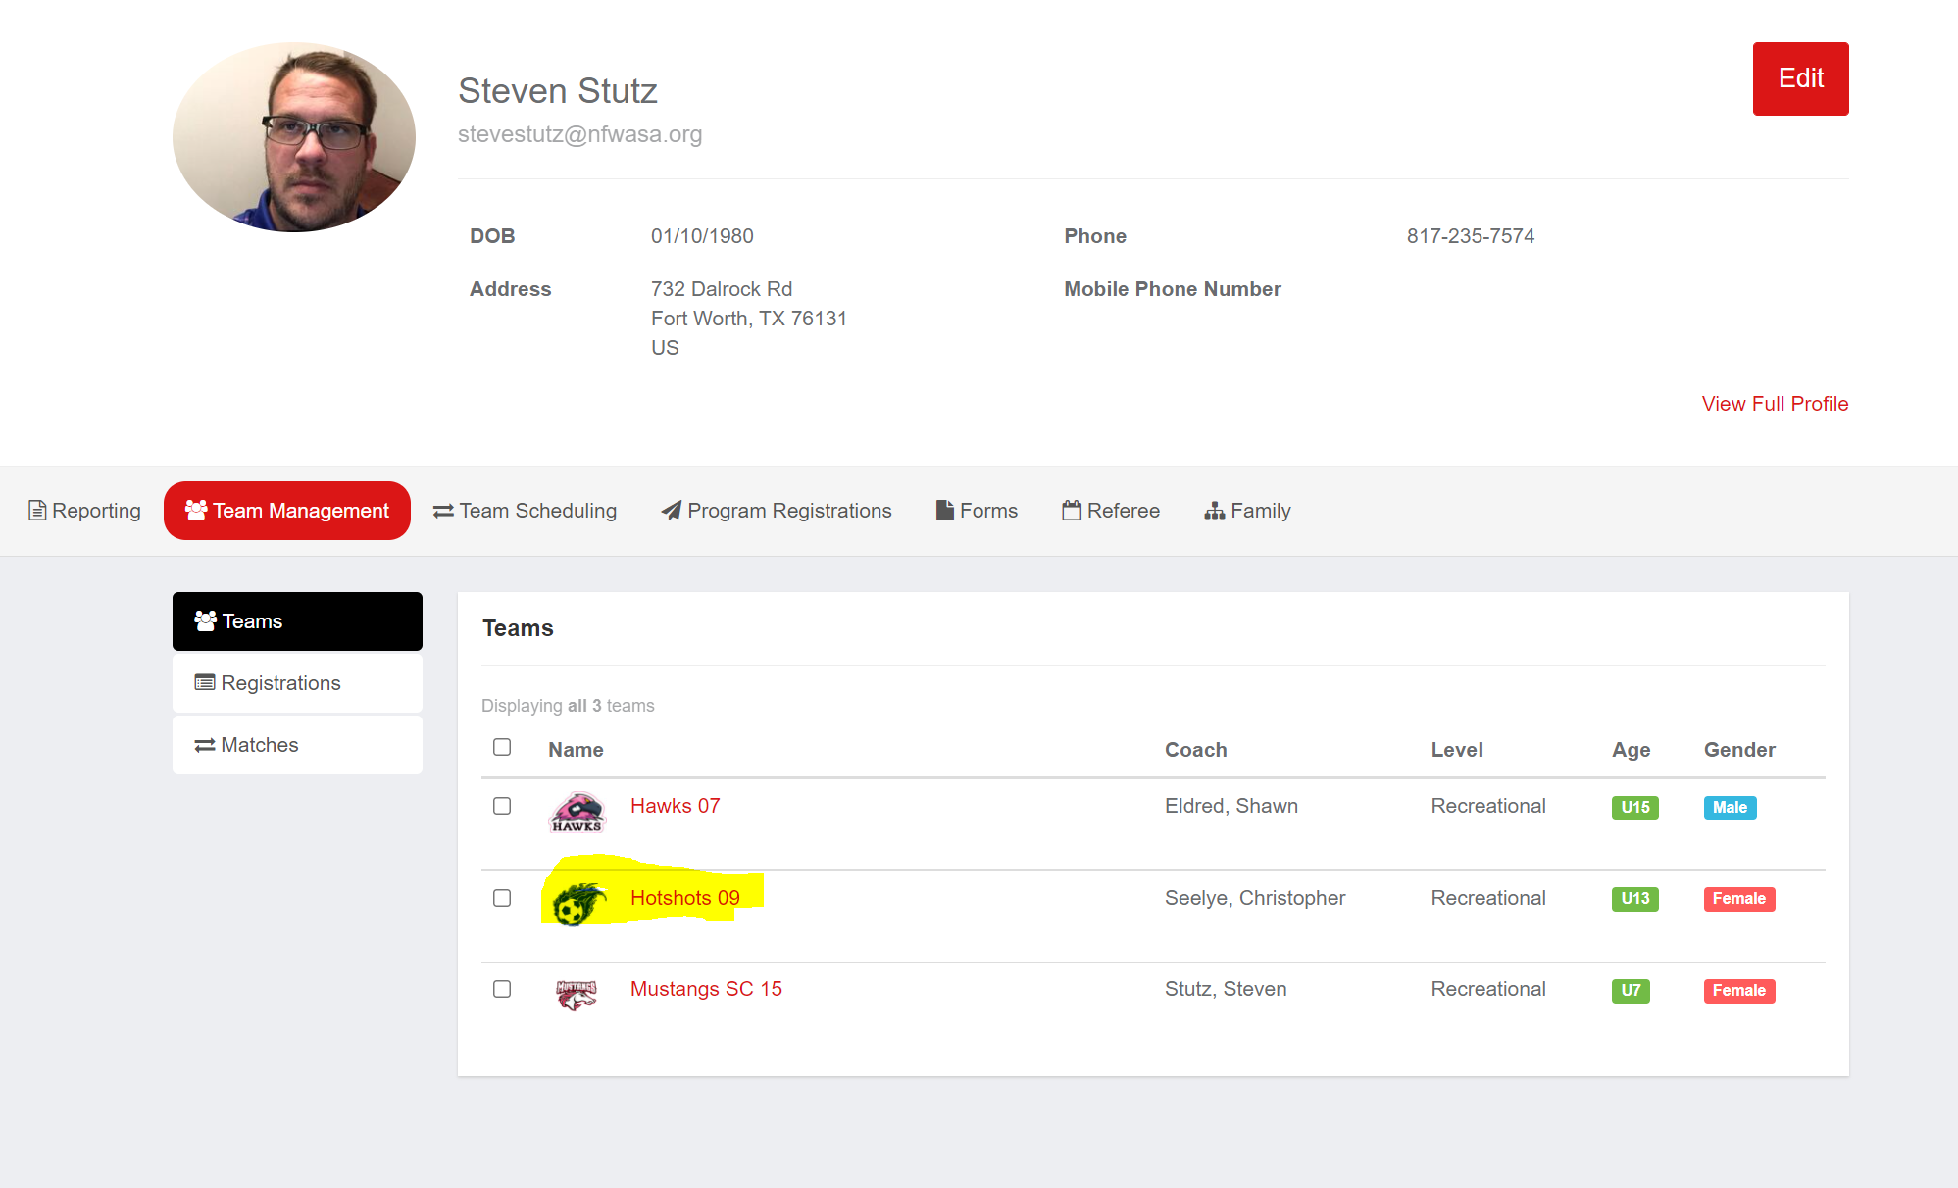

Next select Team Registrations, and then select the current season’s event.
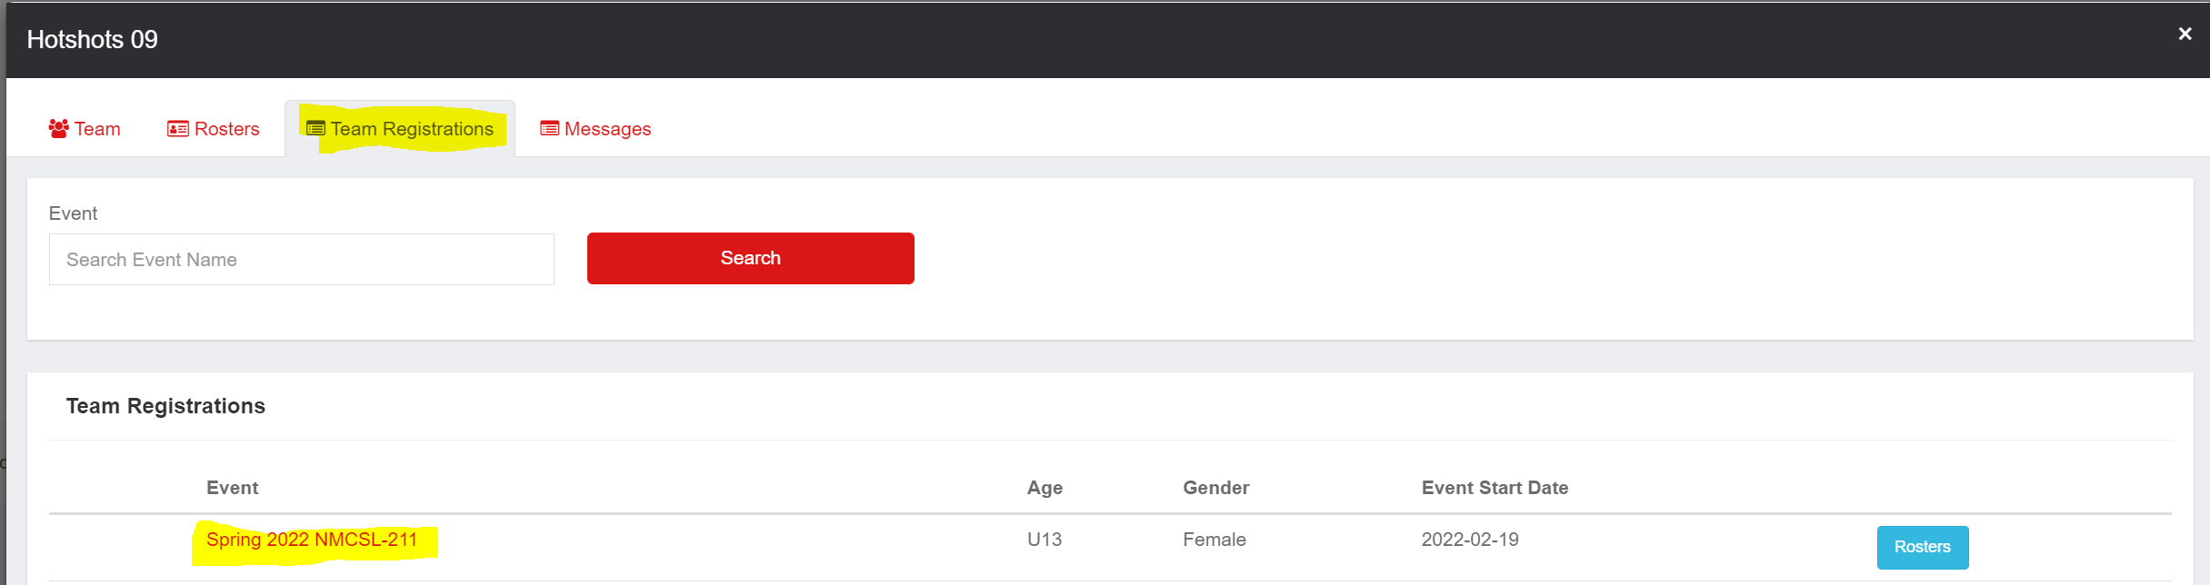

Next click on Schedule, and to the right of each game you will see a blue “Rosters” button that you will need to click on.
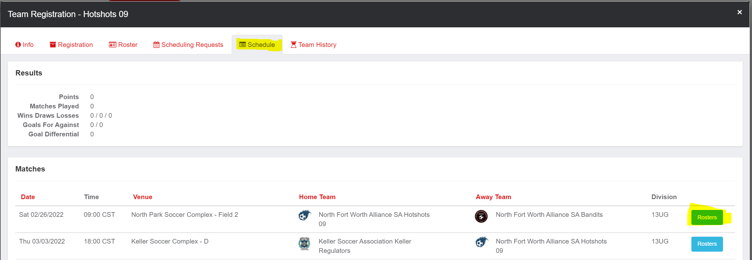

Finally, you will see some options on the right hand side for your Match Card, select the one without photos.

